**Install Jenkins with Docker**

# Install

## Install on Docker

* Run the docker:

|  |
| --- |
| docker run --name jenkins-dev \  -u root \  -d \  -p 8080:8080 -p 50000:50000 \  -v /srv/jenkins_home:/var/jenkins_home –restart always \ jenkins/jenkins:lts |

All the configurations are in the directory “/srv/jenkins_home”.

* Unlock Jenkins install

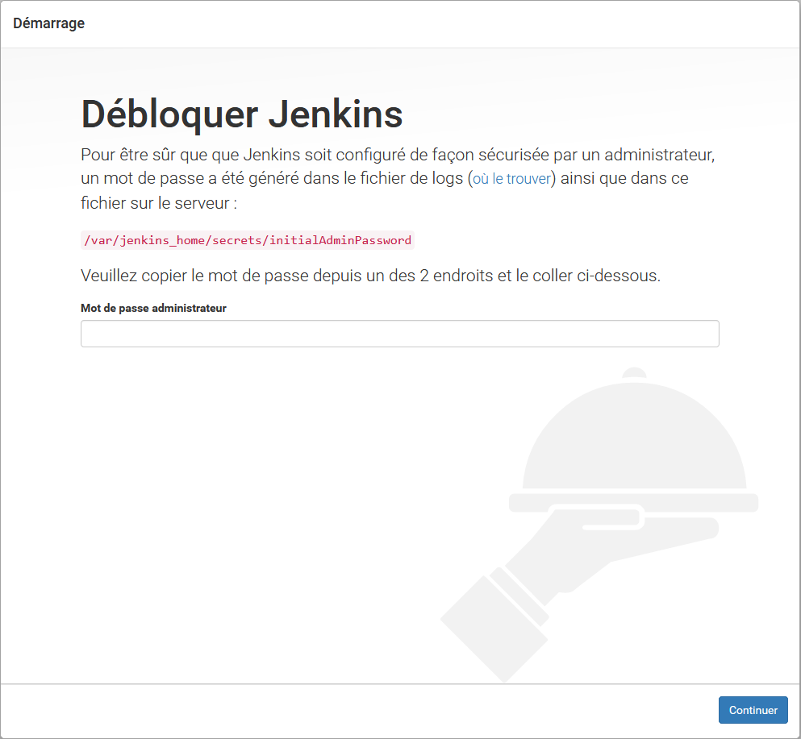Open your favorite browser and go to <http://IP:8080> . You will see that:

To see the password:

cat /srv/jenkins_home/secrets/initialAdminPassword

* 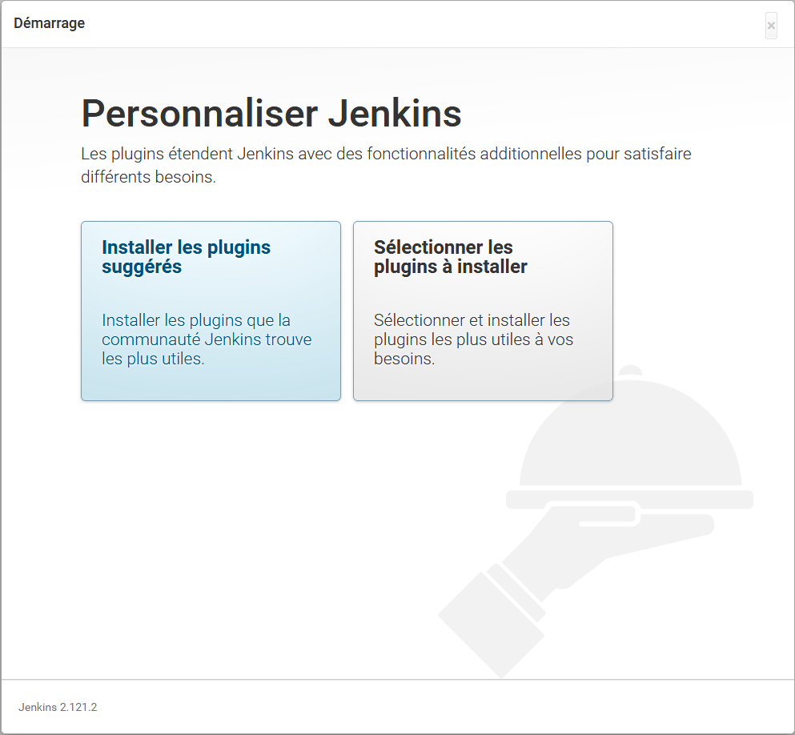Choose plugins:

You can pass the task “create user”, you can do this after if you want…

* Change admin password

Now it’s the password store in the file « /srv/jenkins_home/secrets/initialAdminPassword »

* Admin 🡪 Configurer 🡪 Mot de passe
* Sources: <https://jenkins.io/doc/book/installing/>

<https://github.com/jenkinsci/docker/blob/master/README.md>